SILVER JUBILEE
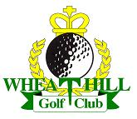
1993-2018

SILVER JUBILEE MEN’S OPEN INVITATION STABLEFORD
4 BALL BETTER BALL, SUNDAY 29th APRIL 2018
KINDLY SPONSORED BY
PETER GREEN chilled TRANSPORT

This is an invitation for members from other clubs to partner Wheathill members.
18-hole 4 ball better ball pairs stableford
90% handicap (max 28) off the white tees
All players must have recognized CONGU ‘Active’ h’cap
PRIZES for First, Second and third positions
Nearest the pin on all par 3’s
Nearest the pin in 2 (14th hole)

ENTRY FEES, GUESTS £25,
MEMBERS £15, (5-Day member £20)
This includes all prizes and a meal after your game
Closing date 20th April
Thanks,
Charlie Anderson (Club Captain)

