

**MINUTES OF THE WHEATHILL GOLF CLUB MAIN COMMITTEE MEETING HELD ON 26th June 2019**

PRESENT:

Janette Stewart-Burnett JSB Chair

Geoff Brewin GB Club Captain

Ann Gates AG Ladies’ Captain

Pete Dunford PD Club Secretary

Chris Whyntie CW Competition & Handicap Secretary

Mike Stayner MS Seniors’ Captain

1. **Introduction** JSB opened and 18:30
2. **Apologies**

Apologies were received from, Dave Gregory, Jill Byrne and Andrew England

1. **Minutes of the Last Meeting 24th April 2019**

The Minutes of the last Meeting were agreed, proposed by AG and seconded by CW

**4. Matters arising from previous meetings**

Matters arising were addressed either at the appropriate agenda items or as follows:

**Archiving**

The archiving of club data is in hand but due to time constraints and the size of the task is taking longer then anticipated to complete. PD was requested to circulate what was available

**Action: PD**

1. **Secretary’s Report and Correspondence.**

PD reported:

Nothing to report

1. **Handicap & Competitions Secretary’s Report**

CW Reported:

CW has produced a list of those members who have permitted access to the scorecard cupboard.

They are

Ladies Section: Judith Rowsell and Sue Harrop

Men’s Section: Chris Whyntie, Pete Dunford & Chris Moore

Seniors Section: Rob Hardy & Alan Frith

Juniors Section: Jill Byrne

The keys are now being retained in the Pro Shop

1. **Treasurer’s Report**

DG reported:

Nothing to report, accounts attached as Appendix 1

1. **Captain’s Report**

GB reported:

Hello all, since our last meeting it feels like we have sliced through halve the summer all ready, would just like to step back too May, and thank Dave and Jen for their very pleasant birthday evening with golf and supper. Along with the x country evening this was well attended.

I have never put so much info into a diary as I am this year, league games after league games competition match’s, think I may have entered too much.

Well done to the senior’s on taken part in their club championship, even though the first round was played out in a monsoon. Congratulations to Chris Hyldon and Tony Tucker.

On June the 6th we had our first Aid training and refresher on the De fib, we had a good attendance with 12 people, would like to thank Allan Frith who organised the training.

Good luck to all who are taken part in the men’s club championship on the 29th and 30th of June, looks like it’s going to be a hot one.

The mixed charity Bowmaker held on Saturday 22nd well-organised and very well supported, well done to Ann and her team.

Excuse me now will I stick my head back into the Diary to see what’s next to be played.

1. **Management Report**

AE reported:

The golf course is playing well from tees, fairways, surrounds, approaches and greens. The rough is a little punishing and the clover hides the balls, so this is being sprayed and the rough will be trimmed back after the Club Championships.

The greens will be treated and surrounding blemishes top-dressed.

Simon is doing a good job and he’s learning the Wheathill ways as he goes all the changes the erratic weather is bringing. He welcomes constructive feedback so chat to him when he’s about.

We will be cutting a fairway strip from tee to fairway and tees to green on Par 3’s.

We are hoping to welcome Becky back after a serious health scare. Good luck on her recovery.

The new benches and brollies are on the patio and a plaque for Patrick will be screwed to one of them.

1. **Ladies Section Report**

AG Reported:

Since our last meeting the ladies have played 3 interleague matches. We drew at home to Worlebury 3 ½ – 3 ½, beat Oake manor at home 5-2 and lost away to Farrington 4-3. We have also played a rogers cup match, and I was delighted to win 4-3 against Clevedon at Saltford. As a reward we play Bath, last year`s champions at Oake Manor on July 12th. Unfortunately Kate Cleverley and Sue Bamping lost their Centenary plate match against Enmore at Wells.

There have been a number of competitions including the Maryland Classic, which was won by Kath James and the Past Captains trophy, which was won by Linda Johnson.

The Charity Bowmaker was a big Success with 16 teams entering, and all enjoying themselves. With the help of sponsors, almost £800 was raised for Canine Partners.

We now look forward to the Championship to be played on July 7th, closely followed by an interleague match at home to Farrington and the Rogers cup match.

1. **Seniors’ Section Report**

MS Reported:

The Seniors have played four friendlies since our last meeting.

Two home matches, against Cannington and Worlebury, we won both

Two away matches against C-S-T and Vivary Park, we lost both.

So far this year we have won all the home matches and lost all away games.

The Seniors Avalon Squad results so far are:

Seniors Somerset Bowl- 1st round beat Minehead, 2nd round beat Long Sutton.

League matches-

Taunton & Pickeridge Away- match drawn

Cannington Home- match won

C-S-T Home-match won

It was requested by the Senior's Committee that I should commend Simon on his green-keeping and relay this information to Andrew England, this I have done.

I had intended to ask at this meeting if we could have a landing area in front of the first hedge on the 16th to enable the Seniors to lay up, Simon has already prepared the landing area and the Seniors are grateful.

From a financial view things are going as they should. The BHF day was a success and a cheque for £2200 is on it's way to the BHF.

The Senior's Championship was won by Chris Hyldon who by doing so was entitled to play in the Stay Sure Pro-am with Mark Singleton. Unfortunately he will be abroad on the day of the competition and is unable to participate. His place was offered to the Championship runner-up, who has accepted the chance.

1. **Junior Section Report**

JB Reported:

Since the last meeting the Junior Squad have played in three of the four league Events at Taunton and Pickeridge, here at Wheathill and at Burnham and Berrow. For the first outing we had a full team of five including two new members. The course was in fine condition and the boys enjoyed their rounds but placings in the final results eluded us. A week later on home turf we had a squad of four and Oscar came second in his division winning a medal and two points

for the Club in the running scores. The third event at Burnham and Berrow was in half term and we could only field two players again, with no placings achieved.

Thanks must be recorded for the support of the event at Wheathill from Judith Roswell, David Gregory, Peter Dunford, Tim Wray and Chris Whyntie and of course the Pro Shop, Green keepers and Catering staff, without whom the day would not have been such a huge success. It will be three years before we will be hosts again.

The Junior Open was on Sunday 9th June with 19 entries. Once again my thanks go to Dave Gregory and Judith Roswell who were a huge support on the day with starting, roaming the course and getting the results sorted. On the same day we had the Somerset Girls Mini tour event following on from our Open. Volunteers from the club, Melanie Brewin, Kath James and Pam and Alan Frith acted as accompanying adults and had a superbly entertaining afternoon. It was a great day for Junior Golf, thanks again to the volunteers, to green staff, bar staff and the pro shop.

Last but not least, we played in the junior club knockout competition at home against Taunton and Pickeridge in match play. On a glorious day the boys acquitted themselves well but conceded defeat. Members out on the course including the Club Captain were exceedingly courteous to the juniors letting them play through as necessary. T&P sent a very complementary email by return which has been circulated to those concerned and the club will be congratulated at the County Juniors AGM in October. Thanks to all for your support.

With only two players available on the day for the Junior Championships last weekend, the competition is being rescheduled for the end of August.

1. **AOB**

AE has spoken with the Internet supplier who quoted an extremely high cost to install super fast fibre to the club. Local residents are expecting super fast broadband to be supplied to the local area as part of the Government initiative.

**Action: AE On-Going**

It was also agreed to have a training session on how to reset the Internet connection/computer

CW to contact Club V1

**Action: CW**

PD stated that he has found a source for a second hand kitchen unit, which should be available by the end of May

**Action: Closed, Cupboard installed**

**Communication of Events & Notices (Data Protection)**

The use of integrating the booking system with Club V1 is to be investigated

**Action: Closed**

**Dangerous Play**

DG stated that he had been made aware of a number of incidents of dangerous play by one particular player.

**Action: Closed, Player concerned has been spoken with**

**Supplementary Rounds**

Alan Frith has produced a note analysing the number of qualifying rounds played in a season from the white tees and the number of supplementary rounds played from the

yellow tees. He has concluded that the supplementary rounds account for only 1% of the total. As a consequence of his analysis he is questioning why the supplementary rounds are played from the yellows and not the white tees.

CW stated that CONGU rules state that supplementary rounds should be played from the yellow tees.

MS then raised the issue of the position of the White Tees and the difficulty some senior players had when the tees were further back, he was seeking some relaxation for senior players.

AE stated the tee position is decided upon by the green staff and not the players, some consideration is given on senior’s medal and stableford competition days.

**Action: Closed see entry as AoB**

**Web Site**

JSB had been given a number of confidential comments on the new web site although it was not in use as it was still being worked upon, comments to be passed to AE.

**Action: JSB/AE**

**Fairways**

The seniors section have requested the area in front of the first ditch on the 16th fairway be cut as fairway.

**Action: AE**

The Ladies section has requested that the fairways on certain holes be extended back towards the tee boxes, as many ladies cannot now reach the fairways.

**Action: AE**

**Temporary Greens.**

The temporary greens are now difficult to see can they be marked.

**Action: AE**

**Poor Course and Club House Etiquette**

Dave Gregory has experienced poor etiquette on the golf course particularly with senior members. A list is to be provided to MS

**Action: MS**

At a recent seniors match at Lyme Regis loud and abusive language was being used, unfortunately the incident was not reported to MS at the time so no action was taken.

This type of behaviour must be curtailed and any occurrences reported to a committee member for action.

**Action: All to note**

**Cross Country**

It was agreed that there would be no separate Cross Country event for the Ladies as they can play in the club event.

**Silverware Competitions**

The issue of the extremely high handicaps having an unfair advantage in silverware competitions has the potential of deterring players from entering.

Playing Committee to review the possibility of capping handicaps for certain competitions.

**Action: CW**

**E-Mail Addresses**

It was agreed that e-mail addresses would not be published in the club diary

**Seniors Roll Up Start Times**

MS asked if was possible to review the Roll Up start times. MS to discuss with AE

**Action: MS**

**Flag Pole**

The flagpole is now beyond repair, the cost of a replacement is to be investigated.

**Action: PD**

**Local Rules**

The senior’s section has asked for the local rules to be reviewed in light of the on going debate over the use of yellow tees for supplementary cards.

**Action: PD & JSB**

**Supplementary Rounds**

The senior’s section continues to insist that supplementary rounds of golf should be played from the white tees.

The main committee has answered this request on numerous occasions and maintains its stance that supplementary rounds are to be played from the yellow tees. MS to ensure the seniors section fully understand the decision of the main committee.

**Action: MS**

JSB said that she was delighted on the excellent feedback the club has recently received. Attachments refer

Meeting closed at 19:35

The next meeting will be held at 18:30 on **Wednesday 24th July 2019** in the Club House

Signed: Janette Stewart-Burnett Date: 24th July 2019

Chair

|  |
| --- |
|  |
|  |

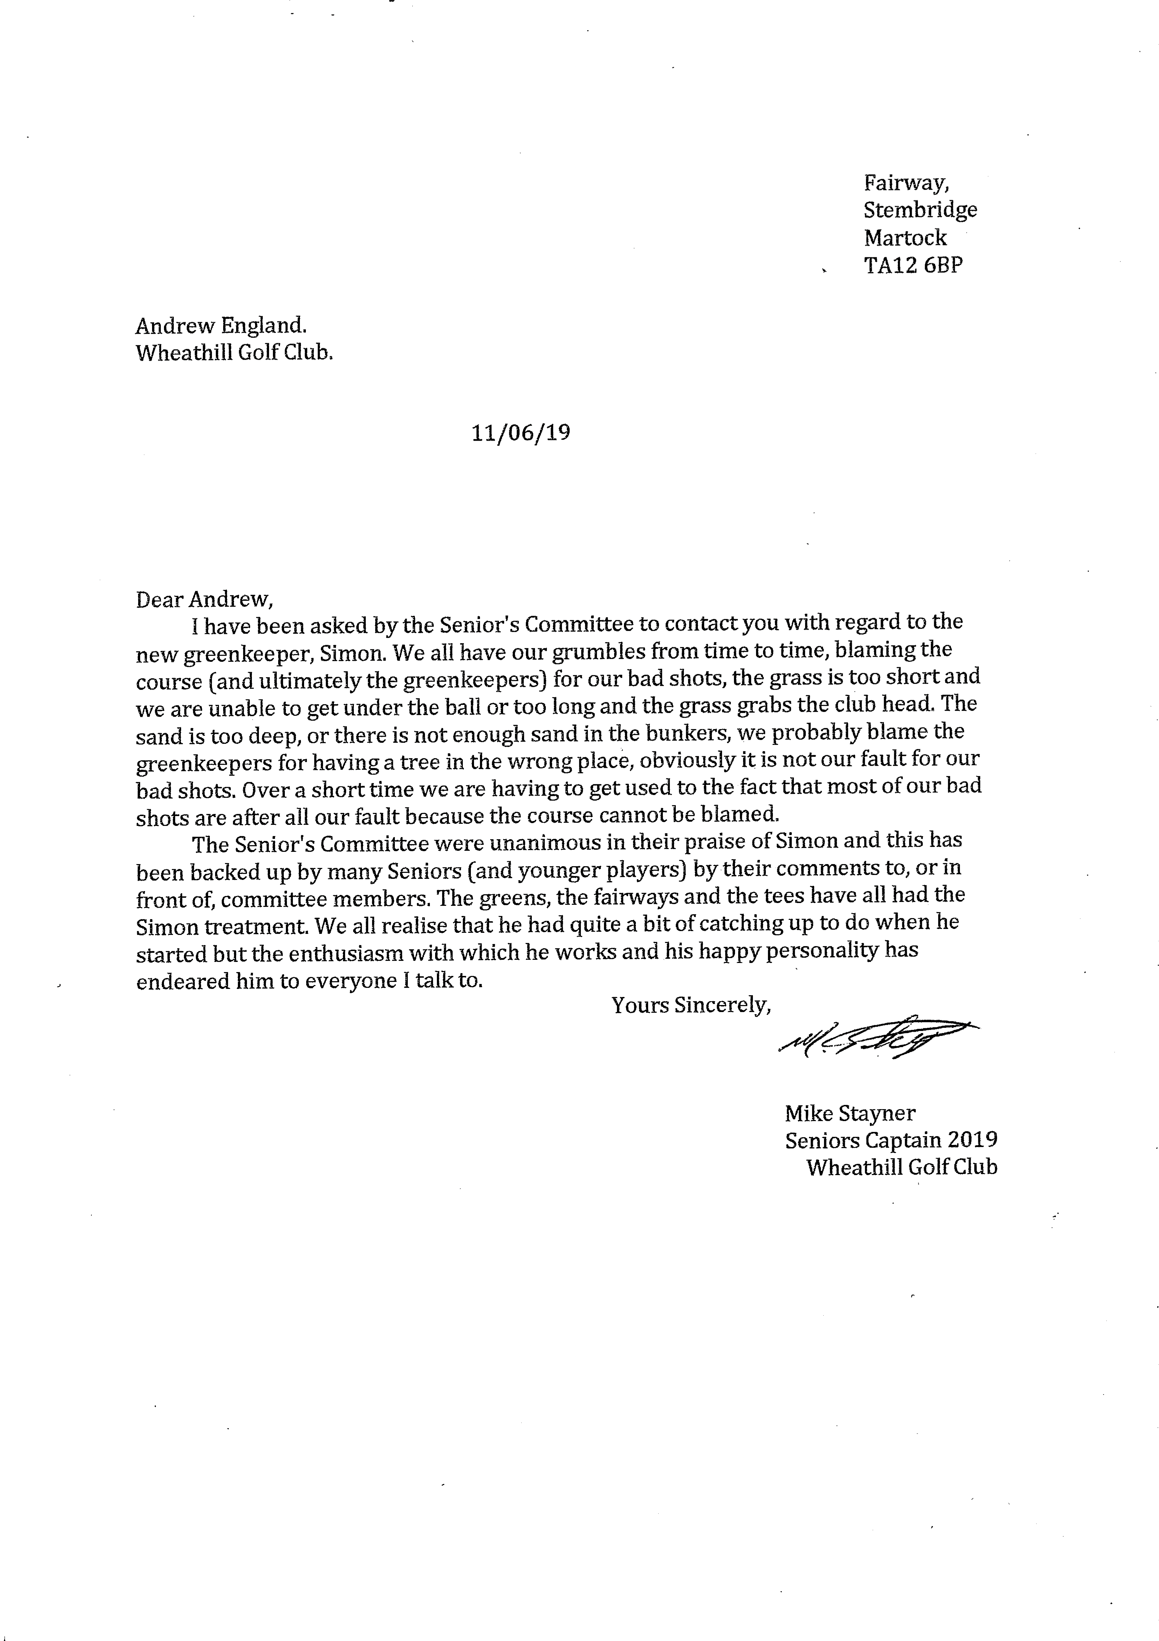

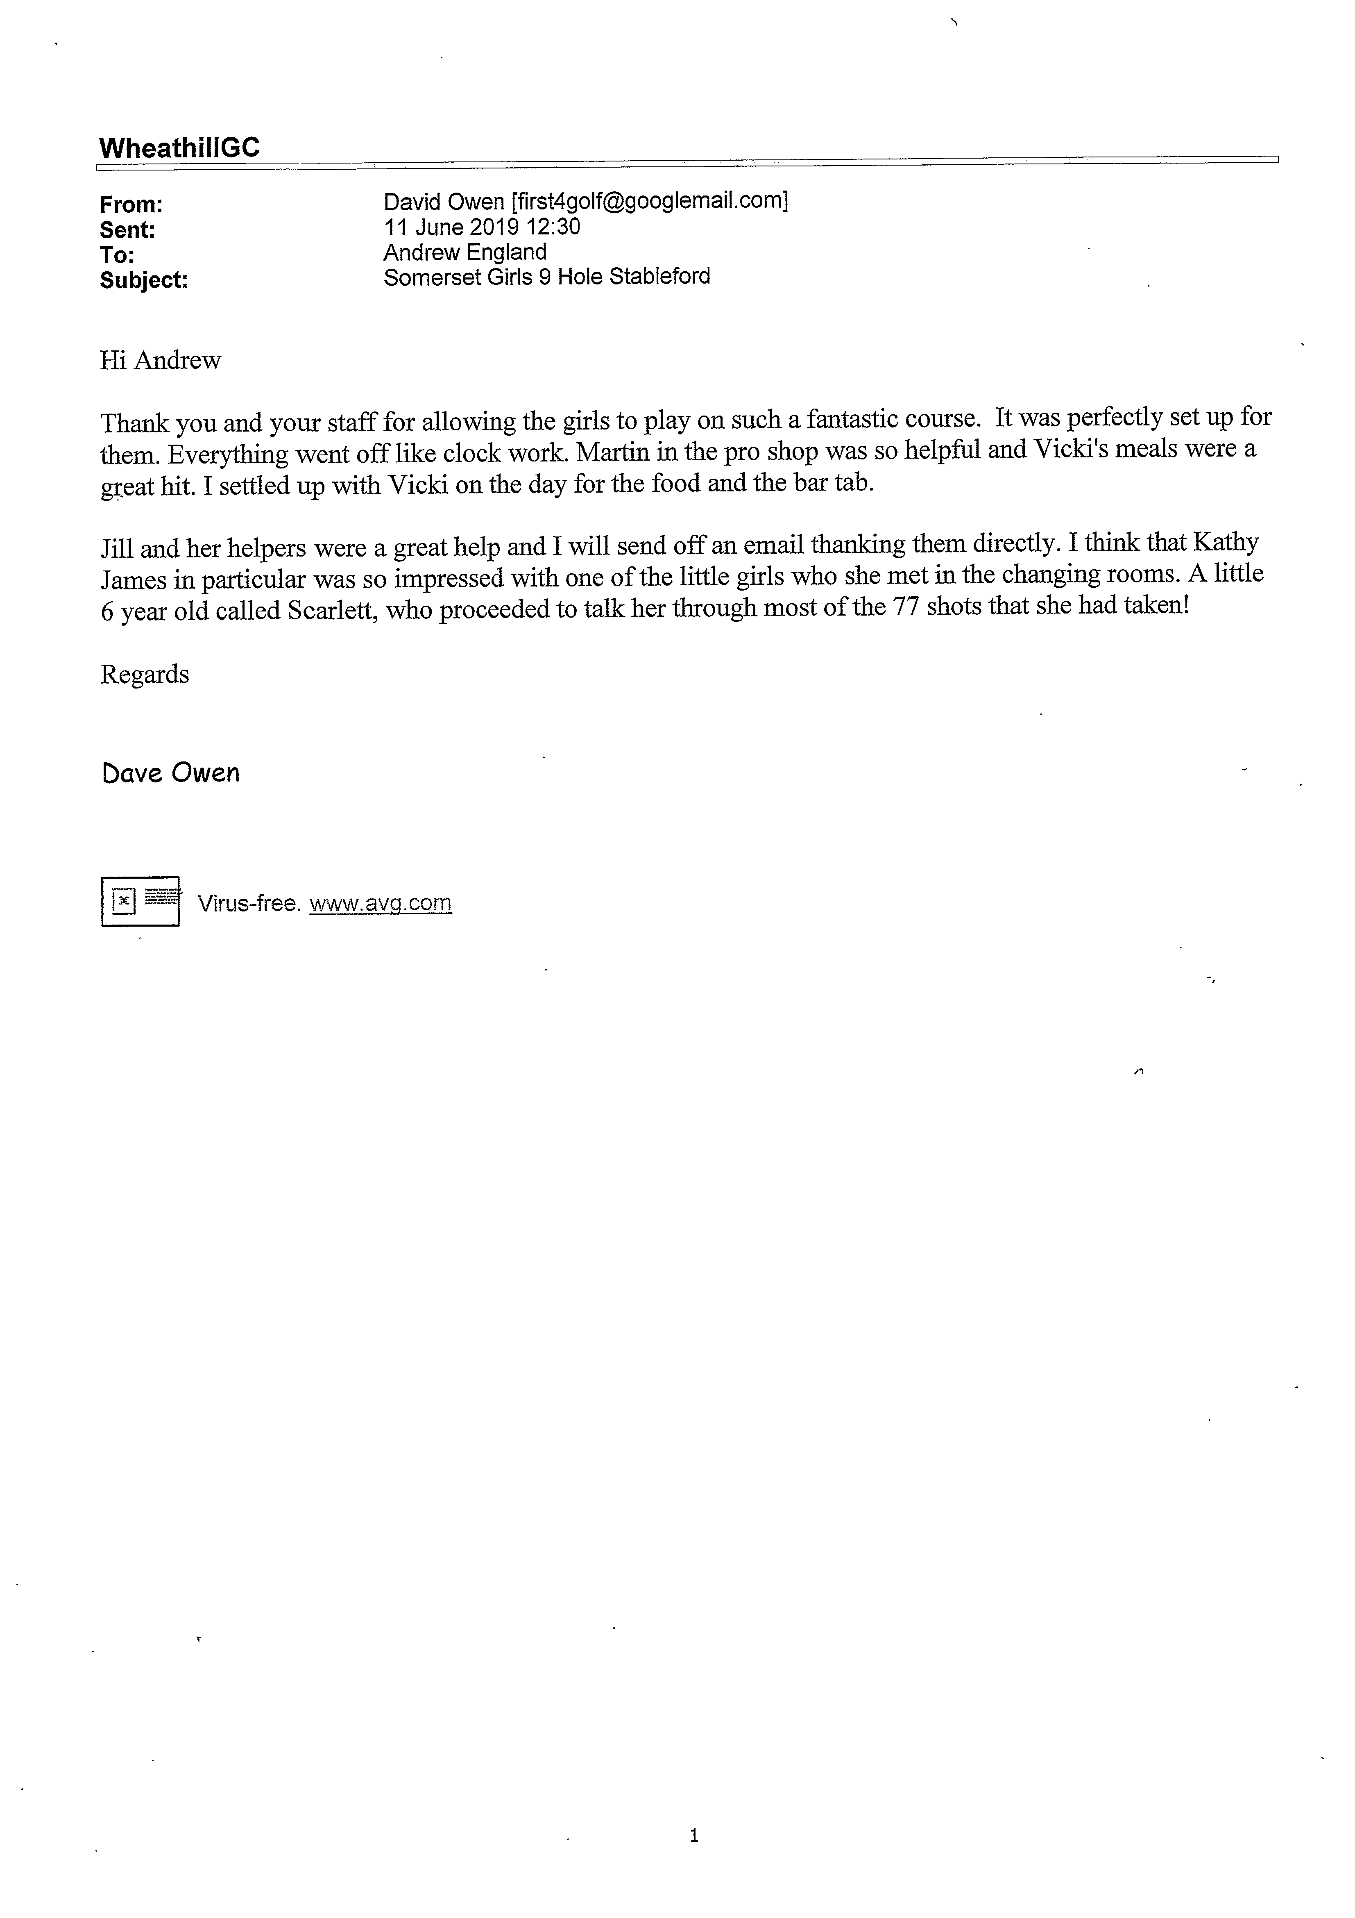

Appendix 1

