

**MINUTES OF THE WHEATHILL GOLF CLUB MAIN COMMITTEE MEETING HELD ON 25th July 2018**

PRESENT: Janette Stewart-Burnett JSB Chair

Pete Dunford PD Club Secretary

Charlie Anderson CA Club Captain

Dave Gregory DG Club Treasurer

Alan Forscutt AF Seniors Captain

Melanie Brewin MB Ladies Captain

Andrew England AE Proprietor

1. **Introduction** JSB opened the meeting at 18:40 and welcomed everybody
2. **Apologies**

CW & JB

1. **Minutes of the Last Meeting 27th June 2018**

The Minutes of the last Meeting were agreed, proposed by CA and seconded by DG

**4. Matters arising from previous meetings**

Matters arising were addressed either at the appropriate agenda items or as follows:

Archiving

The archiving of club data is in hand.

**Action: PD, JB & DG On-going**

1. **Secretary’s Report and Correspondence.**

PD stated that there was nothing to report this month.

The Handicap and Competitions Secretary together with the Seniors Handicap Secretary attended an England Golf presentation on the new rules of golf being introduced in 2019 and 2020.

**Action: Closed**

1. **Handicap & Competitions Secretary’s Report**

No Report

1. **Treasurer’s Report**

DG reported:

That £521 had been paid out for the Club Championship and that left £358 remaining in the funds. The accounts are attached as Appendix 1

1. **Captain’s Report**

CA reported:

Incredibly, the hot weather continues, thunderstorms Friday, warming up again next week, seems no end to the hot dry conditions. I would like to congratulate the green staff for keeping the greens in excellent condition considering the dry weather,

I played at Mendip golf course on Monday; their greens are not as good as Wheathill.

Congratulates to Steve Osborne for winning the club championship last month, also to Kate Cleverley for winning the women’s version. No doubt, Alan and Melanie will update us on the results from the seniors and ladies’ sections, which has been a very busy few weeks.

Some of our league teams has been struggling this season, C team has an outside chance still in their division, the A team have been holding their own in their higher division. Let’s hope all teams have a good run in for the remaining part of the season.

My Captain’s Day went extremely well with plenty of money being made for the Bristol Hospital for Children, supported in the afternoon with the Silver Jubilee Family Fun Day. These sorts of days will only succeed if you have the right people volunteering and giving up their spare time. Well done to Melanie and Geoff Brewin for the running around, before and on the day, also to Alan & Pam Firth, Dave Watson, Elliott and Dan Brewin. Andrew and Martin for giving out some useful golf tips and the B.B.Q and bar staff for completing the perfect day. If anyone would like to know how to maintain their balance on the bouncy castle, don’t come to me.

The Summer Ball tickets for this Saturday (as am printing these notes) are looking rather disappointing, with three league games being played on the same day doesn’t help. This traditional fixture in the club’s calendar may well have to be completely transformed or it will be missing in next year’s calendar,

Finally, the x country competition is being repeated for the second time this season, 5.00pm Tuesday 14th August, due to public demand, this is one fixture, which is well supported,

Keep slapping on the factor 15,

1. **Management Report**

AE reported:

The Pro shop has prepared a quiz to be incorporated with the rules night.

Thanks go to Alan Forscutt for his work restoring the benches.

Congratulations to the ladies teams! We have posted it on Facebook and the website.

The green keepers are doing a splendid job on the greens with great plaudits.

The Mixed Open went well with some very good scores and The Captains Day`s were really enjoyable days for all.

The summer ball 28thJuly and the Cross Country 14th August are our next upcoming events.

1. **Ladies Section Report**

MB reported:

The Wheathill Ladies Team of Lesley Wills, Janette Stewart, Ann Gates, Sue Harrop, Linda Johnson, Jen Warmington and Paula Nankervis beat Enmore at Taunton & Pickeridge in the 3rd round of the Rogers Cup last Sunday. We now take on Saltford in the semi-finals at Well GC.

Les Wills and Molly Shire also won their 3rs round match in the Centenary Plate against Mendip Spring at Enmore park. Their semi final opponents are Worlebury to be played at Stockwood Vale. Busy times for the ladies as both matches have to be played by 19th August.

On one of the hottest days of the year we contested the 36 hole ladies club championship. Umbrellas as sun shades; liberal sunscreen and plenty of fluids were the order of the day. As part of our celebration of the 25th anniversary of the course we welcomed Val Boothman, the first lady captain, to present the prizes. Val made a speech from the heart with why it is important to maintain the tradition of the competition in this format. My congratulations go to all the prize winners on the day but especially Kate Cleverley our Lady Club Champion, a great achievement after giving birth to her daughter Harriet in February this year.

Ann Gates, ladies vice captain, is to be congratulated on organising a very successful mixed open. We had around the same number of entrants as previous years, but the competition was better supported by visitors than members. The day raised the profile of Wheathill and some lady visitors are considering bringing a group of their members to play an away day.

The Captains Fun Day was also successful in a slightly different format for the day and enjoyed by all. The day raised £300 for The Grand Appeal supporting Bristol Children’s Hospital.

1. **Seniors’ Section Report**

AF Reported:

It looks like there is no end in sight to the fantastic weather. Dan as always keeping the course as good as humanly possible.

Would it be possible next time the scorecards are printed to have ABCD on the card instead of the marker. We feel it would be easier to score some matches.

**Action: AE to advise**

There may be some yellow posts missing on one side of the 16th ditch?

Since are last meeting the seniors have played 3 friendly matches, winning 4 to 2 at home to Charminster, unfortunately loosing away to Wincanton but winning 5 to1 home to Long Sutton.

The senior’s captain’s day went well I think, I hope everyone that participated enjoyed the day. My thanks go to Andrew and his team for their support.

Would it be possible to have a set of rules covering Supplementary cards, and would it not make sense to play supplementary rounds off the white tees and make them full qualifiers?

An explanation is to be provided on the clubs supplementary rule policy.

**Action: PD**

Is the club going to adopt the new rule that when a ball is lost a drop can be taken as close to the spot of the lost ball as possible with a penalty.

The use of a stroke & distance local rule for 2019 is to be investigated.

**Action: (Appendix 2 refers) Closed**

Just a note for the main committee that the seniors have now got the finances in a much better state and we even had 90 players in one of our competitions.

Is there any way of advertising to the members that the course is closed for competitions?

**Action: (Complete) Closed**

1. **Junior Section Report**

JB Reported:

No report

It was stated that Martin Liley is attempting to get funding from the SGU to support the junior section.

1. **AOB**

Jim Thorley is to be approached to produce a board upon which to mount plaques in honour of past committee who contributed greatly to the club.

**Action: AF On Going**

PD to provide a plaque with suitable words

**Action: PD On Going**

**Bench Refurbishment**

AF stated that one bench has been completed

**Action: AF On Going**

**Coloured Flags**

Pin position on the 9th green to be displayed in the starters hut.

It was stated that this approach was not practical as the greens are not large enough

**Action: Closed**

**Golf Rules Question and Answer Forum**

The committee in conjunction with AE agreed to hold a golf quiz questions and answers forum, which will be held after this meeting.

**Action: Closed**

JB requested help and support tot the Juniors Open on the 29th July. PD and DG offered to help.

It was agreed to move the Crossman Cup into September

**Action: Closed**

It was noted that the Men’s section has paid for the Ladies section silver jubilee medals.

**Action: Closed**

Members are to be reminded of the disruption caused to competitions and the penalties incurred by failing to turn up to competitions they have entered.

A notice is to be posted on the Notice Board and in the News Letter.

**Action: CA & AE On-going**

**Social Functions.**

The attendance to the Summer Ball was disappointing, which is the current trend for social events.

Considerable discussion was held on ideas to attract more members to social events at the club.

Should the position of Events Organiser be re-instated ?

Ideas to be brought to the next MCM.

**Action: All**

PD asked if the hole map boards could be re-concreted as they are all falling over

**Action: AE to advice**

Meeting closed at 19:30

The next meeting will be held at 18:30 on Wednesday 25th August 2018 in the Club House.

Pete Dunford

Signed: pp Janette Stewart-Burnett Date: 25th August 2018

Chair

|  |
| --- |
|  |
|  |

Appendix 1



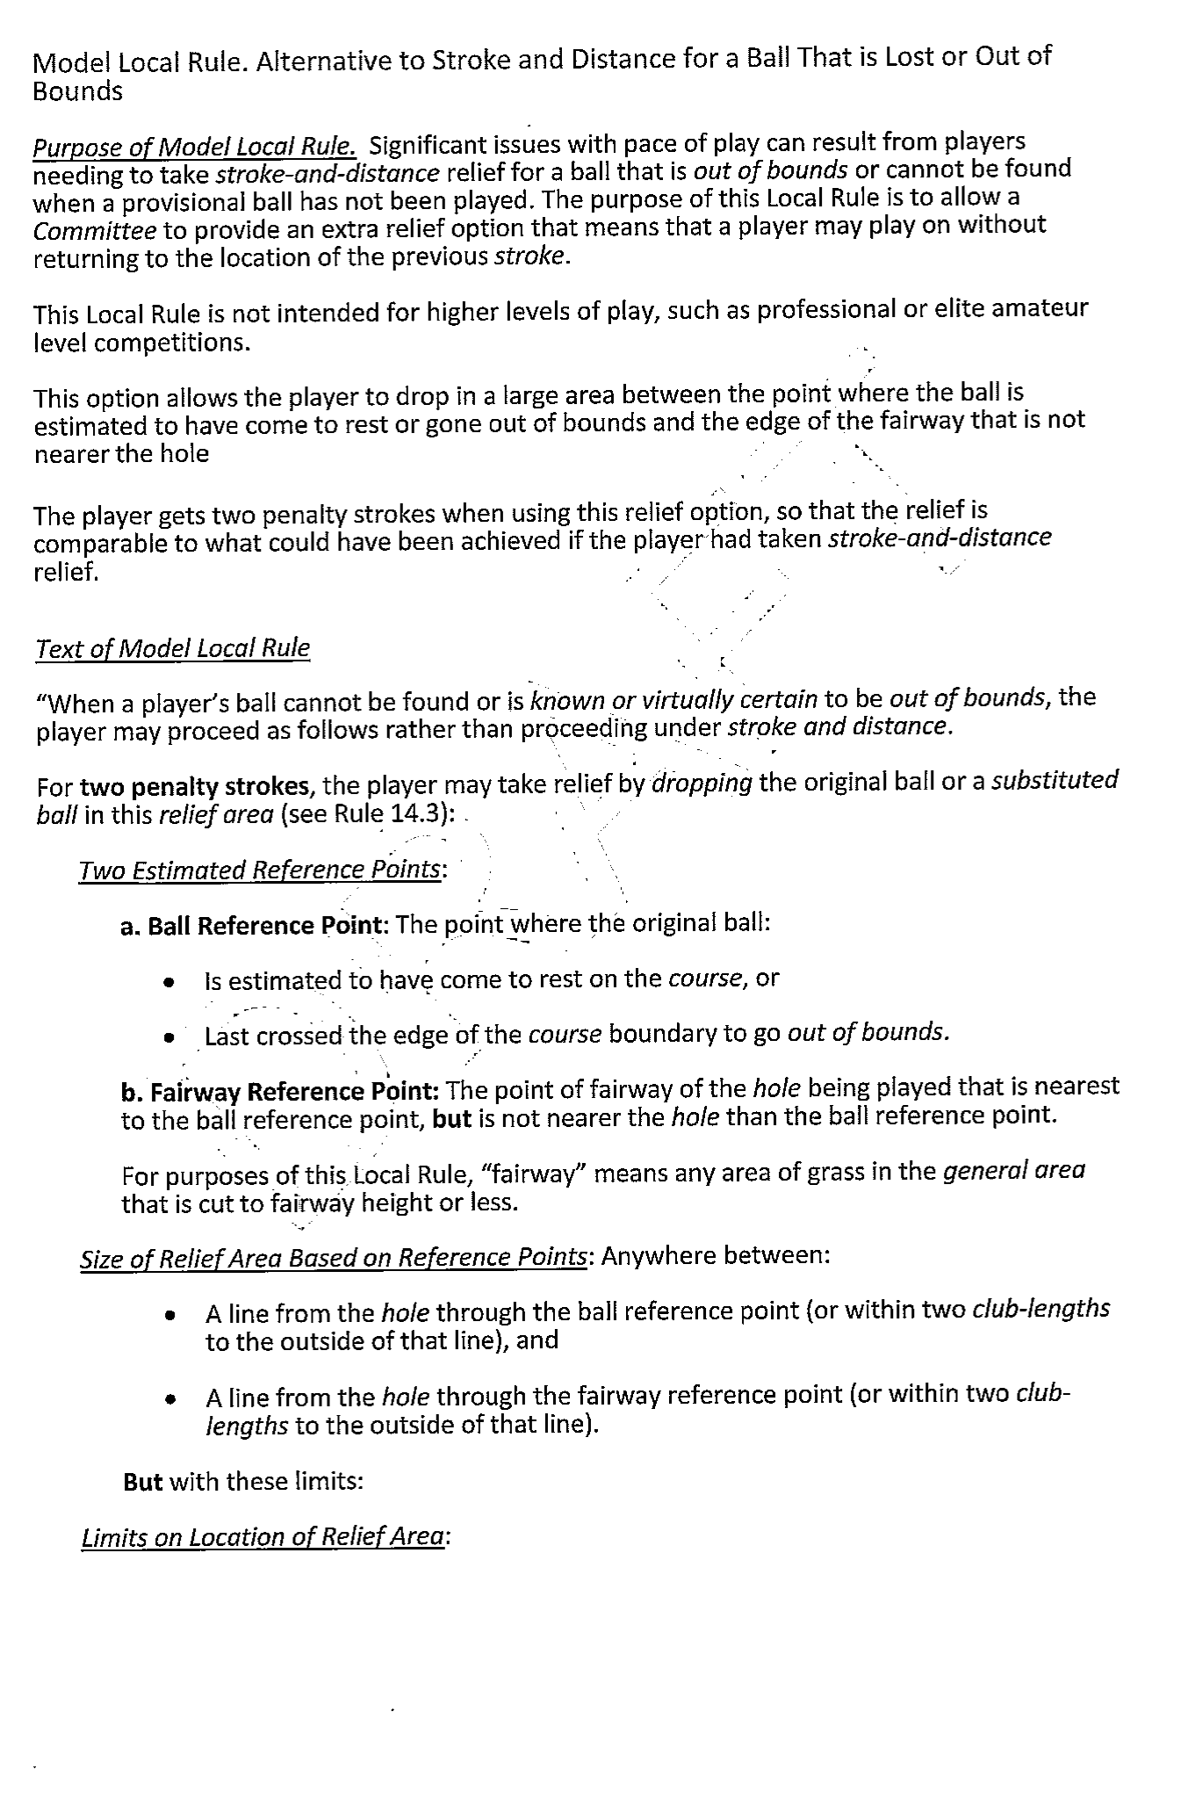

Appendix 2

