

The Minutes of the Wheathill Golf Club Annual General Meeting held in the Club House on 25th November 2021

The Chairperson Mrs Janette Stewart-Burnett opened the meeting promptly at 7:30 pm
Good evening, Ladies’ and Gentlemen and welcome to Wheathill Golf Club’s AGM for 2021.
I hope all of you have managed to access the Wheathill website where the draft minutes for the 2020 AGM are available and in addition the agenda for this evening’s meeting. There are a few copies of both available if need be.
Please all be good enough to sign the attendance sheet. We have received some apologies, which will be published with the meeting minutes
I must thank the management and all of those who devote their time to this club. Those who volunteer their time to committees in various guises. Their time is precious and without them we wouldn’t have the competitions and fun we so readily enjoy.
Sadly, during this year members of our club have passed away. These being: -
John Boothman, Gordon Sperry & Mel Coate, may we just take a minute to reflect on the loss…….
As is customary, any questions you might have for the management team and the main committee will not be answered tonight, they will be recorded and discussed at the next Main Committee meeting and an answer provided through that forum.
On with the meeting.

Attendance and Apologies.
These can be found on Annex A of these minutes.

Minutes of the Last AGM.
The minutes of the 2020 pseudo–Annual General Meeting were circulated prior to the meeting. The Minutes were accepted as an accurate record of the meeting, proposed by Mrs Joan Stone seconded by Mr Chris Reed.

Matters Arising:

There were no matters arising

Senior Captains Report: Mr R Mills

Two years is a long time but some of you may remember when, during my acceptance remarks on taking over the Seniors Captaincy, I said that my golfing friends (we play Mondays and Fridays without fail, unless it’s raining or threatens rain at any time over the next 3 hours……… or 4 hours in the case of certain un-named individuals) were firmly of the opinion that you should never volunteer for anything and NEVER EVER attend an AGM. Privately they told me they thought I was “bonkers” taking on the role of Seniors Captain for 2020.
I, on the other hand, considered it a tremendous honour and went on to say that I hoped to maintain the good name of Wheathill Golf Club amongst our friends at other clubs in the area and to carry on from where my predecessor left off, getting “new faces” involved in Friendly matches. Although I doubted that I would “win over” any of my Monday & Friday golfing friends!
Well, we all know what happened to 2020. So let me say how grateful I was to be given the opportunity to have a second crack at it this year!
Another Lockdown in January and no golf allowed until just before EASTER and then no competitive golf during April (except for our 3 club Trophy- that’s the one where 90% of the players score more Stableford points with two clubs and a putter than they would with a full set of clubs) So no competitions in April was not a start we all wanted!
We were all champing at the bit and eventually we started our season mid-May with a trip to Cricket St. Thomas (we lost). We then carried on right through to our last match in October. We experienced some truly dreadful weather at times and 3 matches were abandoned but our overall tally was: -
14 friendly matches played, 7 wins, 1 draw, 3 Lost and 3 Abandoned.
Now, at this point, I would like to say just a few words about this years’ Seniors committee.
We have 5 separate categories of play in the Seniors section, Friendlies, Avalon League, Monthly Medals & Stablefords, Silverware Competitions and Team events, (Lyme Regis, Enmore Stags, Yeovil, Mendip Spring etc.). So, ideally, we require a committee member to organize each category. This year, Al Frith resigned just as we got back to having face to face committee meetings and soon after that, Richard Pawson announced that he was off to help in the fight against Covid and would not be available for 6 months. We were now two short. If you add into the mix the small matters of not being able to use notice boards or the use of the computer for individual score entry for much of the time you can see that we were “up against it”
The Committee were fantastic, sleeves got rolled up, responsibilities re-distributed and all without complaint. (I think- I’m deaf as a post so I could be wrong on that one!)
I would like to place on record my personal thanks to Andy McDougall, Mike Low and Rob Hardy for all their extra work this year.
I have been very lucky!...........
I would also like to include Paul Wooton, our Treasurer, who completes his second 3 year term of office, and is stepping down.
So, getting back to our year!
There were no Seniors Avalon League matches this year. Mike Low and his team members played in a series of “competitive friendly” matches, giving all members a game. Winning 4 losing 7 and drawing 1.
On the domestic front, we cancelled the January Texas Scramble, Winter League and Eclectic Part Two and in addition the uncertainty about Social Distancing and other COVID related factors resulted in the committee deciding not to run the Seniors Invitational Event or the BHF Day. The Yellow Ball Competition was re-scheduled for later in the year but all other silverware competitions went ahead as planned. Not surprisingly, entry levels were down across all competitions against 2019.
Our Treasurer reports that the Senior Section continues to maintain a very healthy surplus (£1,206.00 + £640.00 entry fees for two teams taking part in the Mendip Spring "Anniversary Trophy" on 1st October, but not repaid by the time the end-of-year accounts were compiled. ………………..They have been now….

So nearly £1850 up £260 from the start of the year.

Seeing as I have just mentioned the Mendip Spring event, I should add here that the Wheathill B team, led by me finished 2^{nd .} overall. The winners being a team from the home club. So we were the highest place visiting team in the competition.
The Seniors Section contributed £60.00 towards the cost of acacia trees to be planted in memory of former Seniors Captain, John Boothman.

They also decided that as from this year the Seniors Section would channel any charity funds raised to the Alzheimer's Association. Following a successful Captain's Day Flag competition we were able to send a cheque to this organisation for £440.00.

So, it’s fair to say …… We have had a successful year
We had to do some things a little differently, relax one or two things here, follow strict regulations there but we have upheld, or maybe even enhanced the good name of Wheathill G.C., Won more friendly matches than we lost, (Lost more Avalon “Friendly” matches than we won) got 15 new players involved and added to the charity fund.
I personally have got to know a lot more people here and made new friends.
I have enjoyed every minute of my time! So, … Not BONKERS then?...........
Of those 15 new players, three are my Monday & Friday mates, I didn’t think I would manage that! Now that is a bit Bonkers……….
I wish Dave and all the other new Captains all the very best for next year.

Seniors Committee for 2021 2022
Captain Dave Gregory
Vice-Captain Ian Barrett
Past Captain Richard Mills
Secretary Andy McDougall
Competition Secretary Rob Hardy
Avalon League Captain Mike Low
Committee Member Jim Williams
Away Day Organiser Pete Dunford

Ladies Captains Report: Mrs J Stone

Well, what a strange couple of years.
Firstly, I would like to thank my committee for their great support over the year. I could not have coped without them.
Due to the restrictions, our committee meetings for much of this year were by Zoom. Thank goodness for technology. It was great when we could finally meet face to face.
I would like to give Dave Gregory a huge thanks for painting Lavender Cottage & laying new tiles in time for us to use after the Christmas lockdown.
Despite the restriction we managed to play most of our silverware competitions. Including the Club Championship in which Kate Cleverley reigned Ladies Club Champion for the 4th year running. Well done Kate. Vicki O’Neill won Best Nett & Anne Carroll received Bronze Gross.
Team golf was also reinstated & Wheathill ladies finished 4th in division 3 in the Interleague. My thanks to everyone who played. There were some tight matches. We will remain in division 3 for 2022. Playing Cricket St Thomas, Oake Manor, Tall Pines, The Mendip & Worlebury.
Wheathill triumphed this year in the Tri-Matches, bringing home the Trophy. Great result! Let’s try & keep hold of it next year.
The Lady Captain away weekend finally happened in September. My thanks to Jan for organising such a fabulous weekend.
Many thanks to Jill Byrne for kindly making masks to sell for my chosen Charity Macmillian cancer care. The total raised for the Charity is £1216.53.
Can I say a big thank you to Ann who has supported me as Past Captain & helped Karen in her new role as Competition Secretary.
Also, of course, Jan, my Vice Captain, who has run the friendly matches and the trimatches. I am sure you will all support her in the same way you have supported me over the past year. I wish her well for her forthcoming year.
Finally, a huge thanks to management, green staff, club house staff and the volunteers. Who have made it possible in difficult circumstances, for us to play Golf & enjoy food & drink in the clubhouse. You all have done a fabulous job.

Ladies Committee 2022

Lady Captain Jan Street
Vice-Captain Jen Warmington
Past captain and County Delegate Joan Stone
Treasurer Sam Thorpe
Secretary Anne Scott
Competition Secretary Karen Forward
Handicap Secretary Fiona Cruse
New Member’s Delegate Sylvia Bates

Juniors Representative Report: report read by J Byrne

I am pleased to report that Junior Golf in the Club has had a successful year which we intend to build on in the coming season when we will be hopefully less restrained by the current pandemic.

In May we had the strongest number of registered Junior golfers on the books with 32 members, though many had not achieved recognised handicaps.

We entered the Somerset League along with 12 other clubs and despite having few players with handicaps we came a creditable 8th out of 13 in the County. Special mention should go to John Angelosanto for achieving maximum points for the team, winning his section of the Event on 2 out of 3 occasions.

We competed in the Jamboree and achieved the same result 8th out of 13 clubs.

The team also entered the Knockout Competition but did not progress to the second round sadly.

Alexander Leonard has been selected to join the County under 12 Development Squad and we look forward to hearing about his progress in this endeavour and hope that we will be able to benefit from his playing skills too in the coming years.

Lastly, we have forged a link with King’s School Bruton whereby the students’ become members of the club, have a programme of coaching and attend on a weekly basis to profit from playing regularly. They will have school matches and be entitled to participate fully in all that membership of the Golf Club includes such as Competitions, fixtures, and handicap regulation. Although in its early stage, we hope this will benefit both the Club and the School in the long run.

Finally, I would like to record my thanks to Oscar Martin for being the Junior Captain during the last two years and to welcome Ollie Miller as our new Junior Captain for the coming season and to wish him a very productive and successful year.

Competitions & Handicap Secretaries Report: Mr D Martin

Handicap Report:
After a year with the World Handicap System (WHS) in place most people are getting used to it but as with most new things it still has a few teething problems:
- Failing to pre-register intent to submit a card.
- Selectively entering cards
When any hole is shortened by more than 10 yards general play cards are not allowed.
A handicap review is underway, you will receive notification if your handicap changes and you will have 14 days to appeal

Competition Report:
This year there was lack of support for all men’s club competitions I am hoping with the return of the diary this will improve next year, please support your club by entering as medals and stableford’s as possible.
A competitions and handicap committee is being formed to make the competition’s and handicapping run smoothly with more people available to answer your questions.
From next year the requirement for entering silverware competitions will be 10 qualifying (Active) cards on a 12-month rolling basis

Treasurers Report: Mr D Gregory

Sadly again this year there is nothing to report due mainly to not being able to have a complete season due to the early season restrictions.
We have not had to complete either the engraving or honours boards from the previous year and so our outgoings are very light.
The attached finance sheet will be a testament to the lack of activity this year, and this the healthy state of the accounts.
The main news to convey is that the seniors account will now also come under the responsibility of the club treasurer, leaving the men’s finances completely in his or her hands.
I hope that that at the end of the coming season, the accounts are brimming with activity which will mean that we have a successful year.
On that point, we have around £1500 tom pay out in the next week or two, that being—presentation night food—captains’ sweaters—benches—engraving and honours boards, so by the end of January the general account will stand at around £2000, still a very healthy state.

Finance Report acceptance proposed by Mrs J Byrne and seconded by Mrs J Stone, and unanimously accepted by the meeting

Club Captains Report: Mr C Reed

I have been told to be quick, so here goes. The last two years have been quite strange and hopefully soon forgotten. A big thank you to Andrew and his staff for keeping us safe, also thank you to all the committee members for running the membership. I hope Steve and Jan will have a great year so our club can move on to a bright new year. Thank you all, happy golfing, and good night.

- Election of officers for 2021/22

Vice-Captain: Mr G Morgan
Elected un-opposed

Result of Club Chairperson Election:
Total Votes cast 158
Votes cast for J Stewart – Burnett 94
Votes Cast for Robert Hardy 49
Void Votes 15

Mrs J Stewart – Burnett is duly elected to serve as Chairperson for the next 5 years

Junior Organiser and Committee Member Mrs Jill Byrne is re-elected unopposed

Team Captains for the 2020 Season
Avalon A: Mr S Osborne
Avalon B: Mr M Hill & Mr M Wright
Avalon C: Mr B Glen
Avalon Seniors: Mr M Low
Three Counties A: Mr D Gregory
Three Counties B: Mr S Moncrieff

Proposed by Mr S Chinnock Seconded by Mr C Reed

The Main Committee will therefore consist of:

Mrs J Stewart-Burnett Chair
Mr S Chinnock Club Captain
Mrs J Street Ladies Captain
Mr D Gregory Seniors Captain
Mr P Dunford Secretary
Mr D Gregory Treasurer
Mr D Martin Competitions & Handicap Secretary
Mrs J Byrne Elected Member (Lady) & Junior Organise
Mr A England Proprietor

- Brief Address by Incoming Captains

Ladies Captain: Mrs J Street

It is a great honour to have been asked to be Lady Captain and I will endeavour to carry out my duties to the best of my ability. When Joan asked me to be her Vice-Captain I was a little nervous but have had the good fortune of working with her for 2 years and hopefully I am now fully prepared for taking over the captaincy. It has not been easy for Joan as Lady Captain due to the pandemic and consequent restrictions, but she has done a great job. Thank you Joan.
I am looking forward to next year with some trepidation but know that I have tremendous support within the ladies’ section from my Vice Captain, Jen Warmington, the ladies committee, past lady captains and our lady members.
Whilst the past 2 years have been difficult for many people, I think that as members of Wheathill Golf Club we have been very lucky – not only because we have been able to play golf, but also because it has provided us with much needed social contact with our friends here at the club. Our clubhouse staff have worked hard to make sure that we can meet here, safely, and I would like to take this opportunity to thank them from the Ladies Section for their cheerfulness and great service.
My chosen charity for next year is Young Minds - a mental health charity. I think children and young people have had a very difficult time due to the pandemic and I am very aware that the mental health services they need are often not readily available – Young Minds works actively to change that and to offer advice and support, not only to children and young people, but also to their families.
Finally, I wish you all a happy and healthy 2022.

Seniors Captain: Mr David Gregory

I have arrived at this point really by default, because of certain circumstances it was decided by the seniors committee to replace the vice-captain and I was asked if I would step in, which I did.
I am honoured to have been captain and now to take on the role of Senior Captain.
I would like to thank Richard Mills for taking on the role for and extra year and for the job well done.
I hope this coming season can and will be fuller year in terms of competitions and get togethers.
I look forward to some good times and lots of enjoyment as we go forward

Club Captain: Mr S Chinnock

Thank you to Chris Reed for asking me to be his Vice and once I decided to accept for the guidance that he gave me

I was a little disappointed with the turnout for the A G M and wanted to explore avenues to increase turnout such as the Seniors Everyone's a Winner

Gave my assurance that I would do all that I could to move the club forward after the troubled times of Covid but that it may rear its ugly head again!!!

Look forward to working with my fellow Captains and with the committee

Management Statement: Mr A England

The club and course are in good shape.
But we will continue to improve things as we always have.
Patience and kindness to our staff please, politeness and manners cost nothing.
The weather has been kind to now and has allowed new bunkers, Tees, and treatments to continue. Leather jackets and worms have been knocked back.
We will be improving surrounds as a matter of priority for next season.
We have had a influx of new members and visitors, so please make them a Wheathill friendly welcome.
Thanks to the committees and good luck to the newbie’s

Any Other Business

There was no other business

Closing Statement From The Chair

I would like to wish the new Captain’s
Steve Chinnook, Jan Street, David Gregory and Ollie Miller and their new committees a healthy and positive 2022.
In addition, I wish to present this new Chairpersons Trophy together with a keepsake to the club to be presented annually to the person most deserving for his or her contribution to the running and well-being of the club.
This year being the first year, I have nominated Mr Alan Frith for his unstinting work for the seniors’ section and for his work in raising money for the British Heart Foundation

- Date of Next Annual General Meeting

The next AGM will be held on Thursday 24th November 2022 at 7:30 pm in the Club house

Signed Date: November 2022

Mrs J Stewart-Burnett

Chair

Annex/Appendix

Annex A Register of Attendees & Apologies

Appendix 1 Wheathill Golf Club Statement of Accounts 2020/2021

APPENDIX 1

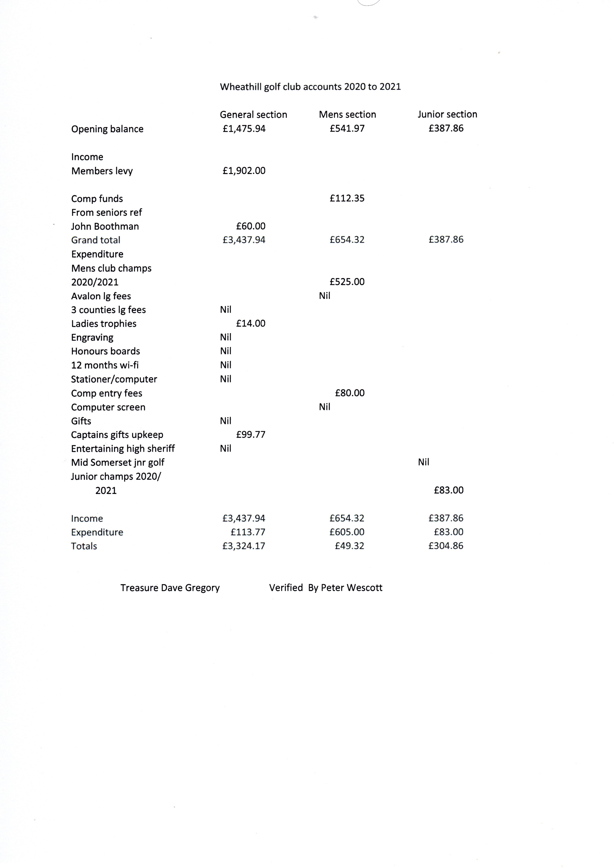

ANNEX A

