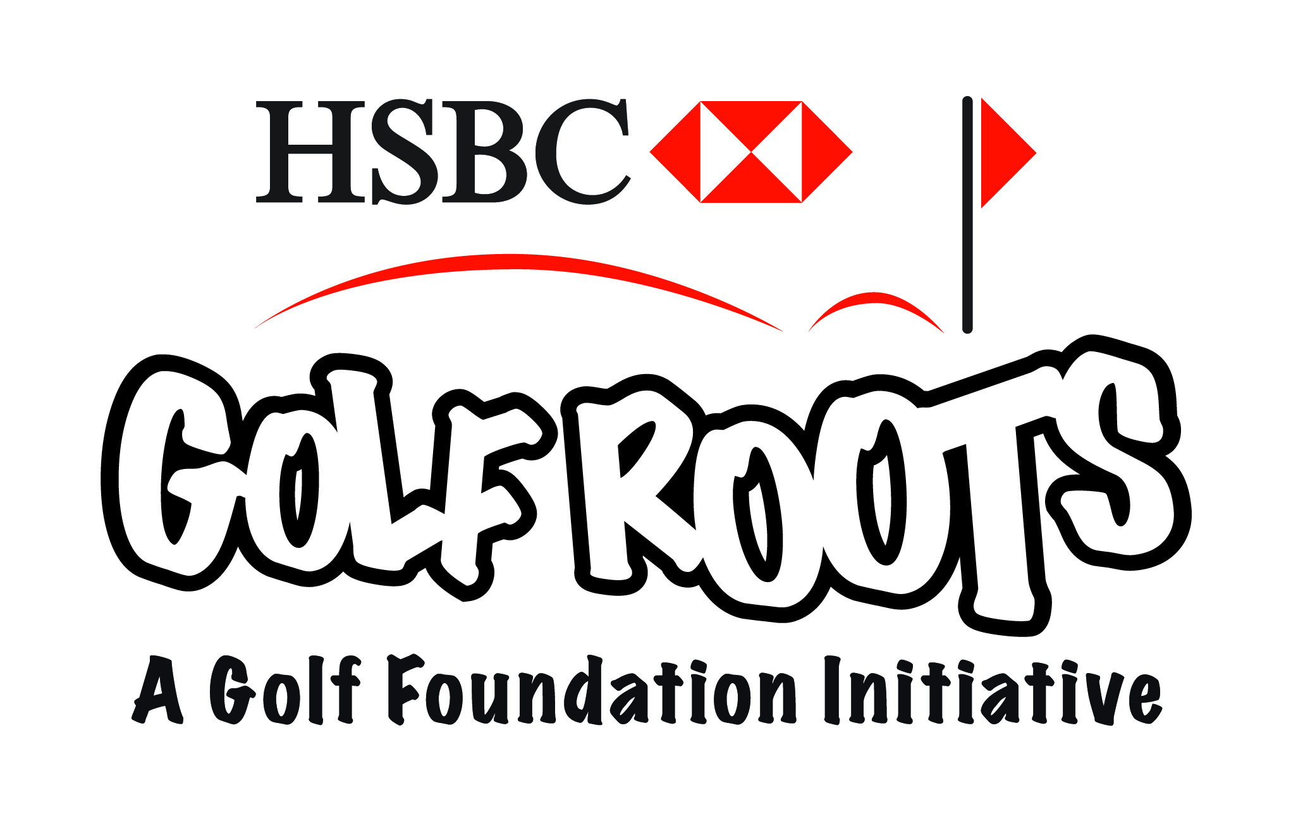
Choice of full or half day camps.
Wheathill is an accredited HSBC Grass Roots facility so is the perfect place for your Children to learn golf! All Children welcome no experience needed!

10am-3pm Full Day cost £20, Available Dates:
Friday 6th April (Easter Holidays)
Monday 6th August (Summer Holidays)
10am- 12pm Half Day cost £10, Available Dates:
Friday 1st June (Summer Half Term)
Monday 20th August (Summer Holidays)
To book a place on our junior golf camps just call us on 01963 240667 opt 2.
Don’t Miss out only 12 Places per Date!
All balls and equipment will be provided but packed lunch must be brought on the Full Day Camps.

